DIS-EUR-Thrace-Thracian Horseman

Marble votive tablet of a Thracian horseman, 2nd century AD/CE, probably from the Madara Plateau, Bulgaria, based on its similarity to other votive tablets in the Madara Museum. H 16 cm , W 15 cm

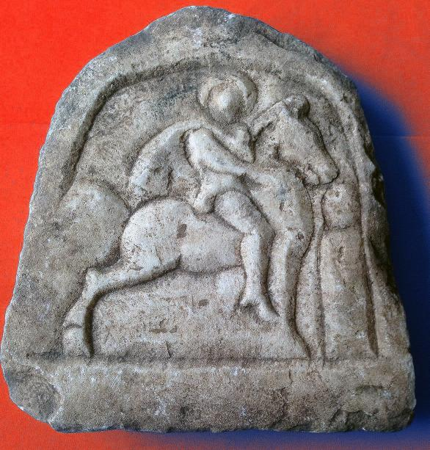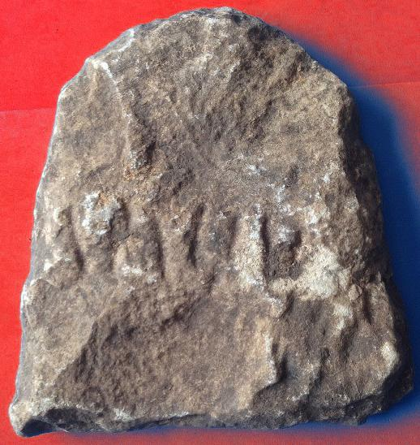

**The Thracian horseman** (Bulgarian: *Тракийски конник*) refers to a horseman deity dating to Paleo-Balkan mythology. In this Roman Period rendition the caped horseman with a halo is seated astride an erect, stationary steed, with his left hand holding his cape and his right hand pointing to an erect anthropomorphic corpse, as though he is offering a benediction to the dead. This iconographic portrayal suggests that this votive plaque was, therefore, intended for a deceased cavalryman.

In other iconographic portrayals of the Thracian Horseman he is often depicted as slaying a beast with a spear held in his right hand and sometimes accompanied by a hunting hound. A petroglyph-relief east of Shumen in northeastern Bulgaria, near the village of Madara is dated late 7th early 8th century, during the reign of Bulgar Khan Tervel (Petkov 2008: 5; see figure below). This relief testifies to the duration of the cult as it developed in Bulgaria only to finally merge into the image of St. George slaying the dragon.

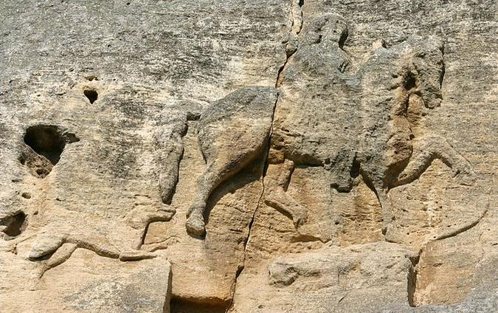

Bas relief petroglyph/relief of the Madara Horseman on the Madara Plateau accompanied by his trusty hound and his horse trampling on a lioness.

The motif typically features a caped horseman astride a steed, with a spear poised in his right hand. He is often depicted as slaying a beast with a spear, though this features is sometimes absent.[[1]](https://en.wikipedia.org/wiki/Thracian_horseman" \l "cite_note-1)[[2]](https://en.wikipedia.org/wiki/Thracian_horseman" \l "cite_note-Nicoloff-2)[[3]](https://en.wikipedia.org/wiki/Thracian_horseman" \l "cite_note-3) The tradition is best illustrated in surviving artifacts from [Thrace](https://en.wikipedia.org/wiki/Thrace), [Macedonia](https://en.wikipedia.org/wiki/Macedonia_(Roman_province)), [Moesia](https://en.wikipedia.org/wiki/Moesia), and [Scythia Minor](https://en.wikipedia.org/wiki/Scythia_Minor) dating to the [Roman era](https://en.wikipedia.org/wiki/Roman_Empire), and is often found depicted on funerary statues.

### References

### Petkov, Kiril (2008). The Voices of Medieval Bulgaria, Seventh-Fifteenth Century: The Records of a Bygone Culture. London: Brill.

### Delivery package 1 of 1

Estimated delivery Tuesday, Jun 14, 2016 - Tuesday, Jun 21, 2016

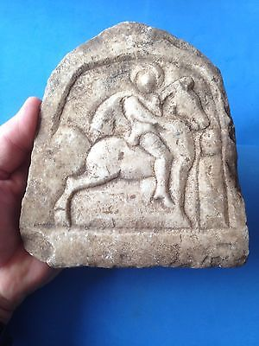

#### [THRACIAN HORSEMAN /RARE ANTIQUE VOTIVE TABLET](http://www.ebay.com/itm/322120592087)

|  |  |
| --- | --- |
| Item price | $544.41 |
| Quantity | 1 |
| Item number | 322120592087 |
| Shipping service | Royal Mail International Tracked |